Practical: 5 | To implement the 0/1 Knapsack Problem using Dynamic Programming in C++ and determine the maximum value that can be obtained within the given knapsack capacity.
12/07/2026

Aim: To implement the 0/1 Knapsack Problem using Dynamic Programming in C++ and determine the maximum value that can be obtained within the given knapsack capacity.

ALGORITHM:

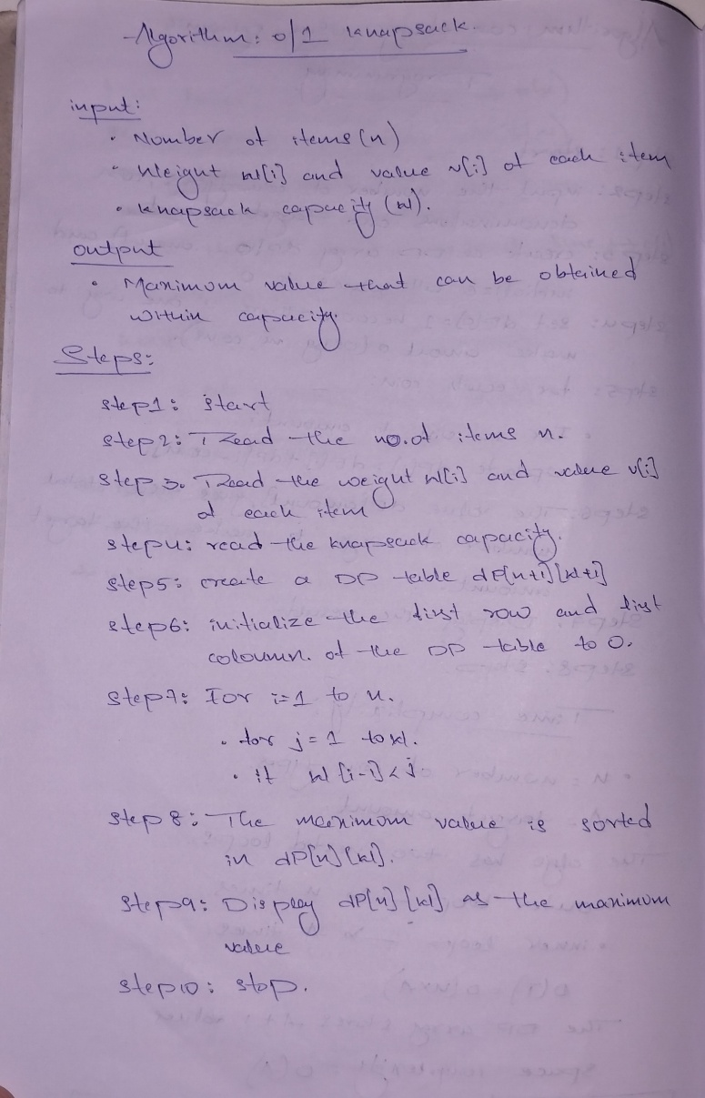

Program:
#include<iostream>
using namespace std;

class Knapsack {

private:
int w[10];
int v[10];
int n;
int W;
int dp[10][100];

public:
void getInput() {
cout << "Enter number of items : ";
cin >> n;
cout << "Enter knapsack capacity : ";
cin >> W;
for(int i = 1; i <= n; i++) {
cout << "Item " << i << " weight and value : ";
cin >> w[i] >> v[i];
}
}

void solve() {

for(int i = 0; i <= n; i++) dp[i][0] = 0;
for(int j = 0; j <= W; j++) dp[0][j] = 0;

for(int i = 1; i <= n; i++) {
for(int j = 1; j <= W; j++) {

if(w[i] <= j) {
dp[i][j] = max(
v[i] + dp[i-1][j-w[i]],
dp[i-1][j]
);
} else {
dp[i][j] = dp[i-1][j];
}
}
}
}

void printTable() {
cout << "\nDP Table:" << endl;
cout << " ";
for(int j = 0; j <= W; j++)
cout << j << " ";
cout << endl;

for(int i = 0; i <= n; i++) {
cout << "i=" << i << " ";
for(int j = 0; j <= W; j++)
cout << dp[i][j] << " ";
cout << endl;
}
}

void findItems() {
cout << "\nSelected Items:" << endl;
int j = W;
for(int i = n; i >= 1; i--) {
if(dp[i][j] != dp[i-1][j]) {
cout << "Item " << i
<< " (w=" << w[i]
<< ", v=" << v[i]
<< ") TAKEN " << endl;
j = j - w[i];
} else {
cout << "Item " << i
<< " (w=" << w[i]
<< ", v=" << v[i]
<< ") NOT taken " << endl;
}
}
}
void showResult() {
cout << "\nMaximum Value = "
<< dp[n][W] << endl;
}
};
int main() {

Knapsack k;

k.getInput();
k.solve();
k.printTable();
k.showResult();
k.findItems();

return 0;
}

Output:

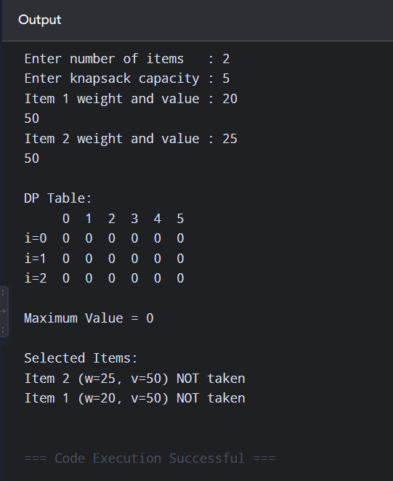

Time Complexity:

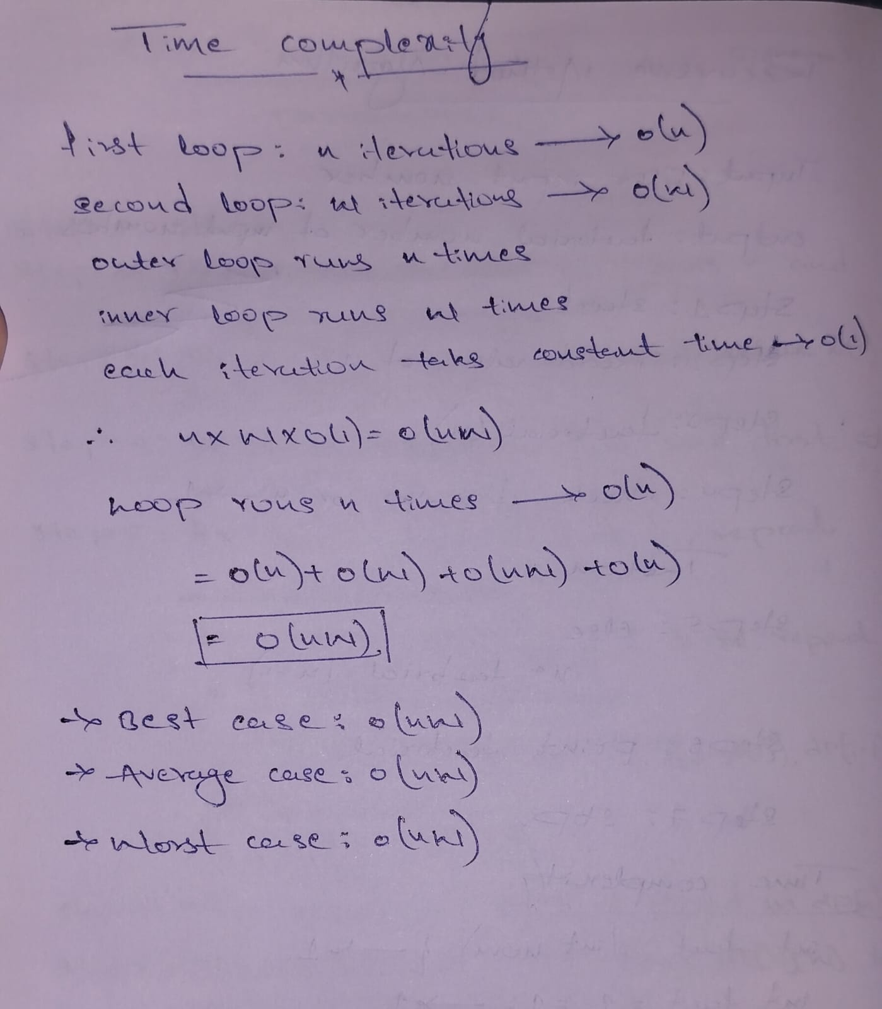

Conclusion:
The 0/1 Knapsack Problem was successfully implemented using Dynamic Programming in C++. The program calculates the maximum possible value within the given capacity and identifies the selected items. The time complexity of the algorithm is O(nW).

